Bansilal Ramnath Agarwal Charitable Trust’s
Vishwakarma Institute of Information Technology
(Department of Electronics & Telecommunication)


Internship Report
on
“Building Prototype of an Automated Guided Vehicle”
(SPONSORED BY: Ratna Gears Pvt. ltd)
(Domain: Robotics)
Submitted By:
Roll No. | Division | Name of Student | E-mail | Contact Number
413019 | C | Mayuresh Takawane | mayuresh.17u498@viit.ac.in | 8766445145
413053 | C | Shoaib Shaikh | shoaib.17u425@viit.ac.in | 7709155993
413071 | C | Zahid Hussain | zahid.17u597@viit.ac.in | 7588328007

B. Tech. E&TC
Of
Savitribai Phule Pune University
(Formerly University of Pune)

Under supervision of
Prof. R. S. Pol
Year 2020 – 2021

CERTIFICATE

This is to certify that final year internship project entitled "Building Prototype of an Automated Guided Vehicle ” carried out in the eighth semester by,

Roll No. | Division | Name of Student
413019  413053  413071 | C  C  C | Mayuresh Takawane  Shoaib Shaikh  Zahid Hussain

in partial fulfillment for the award of Bachelor of Technology degree in Electronics and Telecommunication Engineering from Vishwakarma Institute of Information Technology, Savitribai Phule Pune University, Pune during the academic year 2020-21.

Date: 05/06/2021

Prof. R. S. POL Prof. R. S. POL
Name of Guide Name of Coordinator
Guide Internship Coordinator

Dr. S. V. Kulkarni
H.O.D., E&TC Engineering Department.

ABSTRACT

Automated guided vehicles (AGVs) are used for the internal and external transport of materials. Traditionally, AGVs were mostly used in manufacturing systems. Currently, AGVs are also used for repeating transportation tasks in other areas, such as warehouses, container terminals and external (underground) transportation systems. This paper discusses literature related to design and control issues of AGV systems at manufacturing, distribution, transshipment and transportation systems. It is concluded that most models can be applied for design problems at manufacturing centers. Some of these models and new models already proved to be successful in large AGV systems. In fact, new analytical and simulation models need to be developed for large AGV systems to overcome large computation times, NP-completeness, congestion, deadlocks and delays in the system and finite planning horizons. We specify more specific research perspectives in the design and control of AGV systems in distribution, shipment, and transportation systems.

ACKNOWLEDGEMENT

This work could not have been completed without the guidance and encouragement of many people. We would like to particularly acknowledge those below.
We pay our humble regards and gratitude to Prof. R. S. Pol for guiding us and giving moral support and timely boost.

(NAME OF STUDENTS)
MAYURESH TAKAWANE (17U498)
SHOAIB SHAIKH (17U425)
ZAHID HUSSAIN (17U597)

LIST OF FIGURES
- Electronic Circuitry and Power distribution block diagram.
- AGV Operation
- CAD Model – Base
- CAD Model – Drawer compartments assembly
- CAD Model – Single drawer compartment
- CAD Model – Assembled AGV
- Operation Flow chart
- V-REP Simulation interface

INDEX
SR. NO. | CONTENTS | PAGE NO.
 | ABSTRACT ..................................................................................................... | 3
 | ACKNOWLEDGEMENT ................................................................................ | 4
 | LIST OF FIGURES........................................................................................... | 5
1 | INTRODUCTION | 7
2 | LITERATURE SURVEY | 8
3 | OBJECTIVES | 10
4 | MOTIVATION | 11
5 | BLOCK DIAGRAM AND DESCRIPTION | 12
6 | METHODOLOGY | 16
7 | HARDWARE AND SOFTWARE REQUIREMENT | 18
8 | RESULT ANALYSIS AND DISCUSSION | 20
9 | APPLICATIONS | 22
10 | FUTURE SCOPE | 22
11 | PROTOTYPE MODEL | 25
13 | REFERENCES | 29

1. Introduction:
An automated guided vehicle or automatic guided vehicle (AGV) is a mobile robot that follows markers or wires in the floor or uses vision or lasers. They are most often used in industrial applications to move materials around a manufacturing facility or a warehouse. A material handling system that uses automated vehicles such as carts, pallets or trays which are programmed to move between different manufacturing and warehouse stations without a driver.
Most intelligent manufacturing industries will choose a flexible production mode to bring higher production efficiency with the least manpower. This requires the introduction and application of some advanced technical means, such as common materials.
Networking technology, communication network technology, etc. Taking these two technologies as an example, the Internet of Things technology realizes the interconnection between various equipment, systems, and people in the production link, so that the entire production process can be monitored and managed in real time, while technology has greatly improved the original communication.

2. Literature Survey:
Automatic guided vehicles (AGVs) are autonomous vehicles used to transport materials or accomplish specific tasks in many different industrial settings. They feature batteries or electric powered motors and computer technology that has been programmed to drive to and from specific points. Sometimes, since they are controlled by a computer rather than a human, AGVs are referred to as self-guided vehicles, self-propelled vehicles or autonomous guided vehicles.
Arthur “Mac” Barrett built the first automatic guided vehicle in 1953 by modifying a towing tractor so that it followed an overhead wire. His company, Barrett Electronics Corporation, debuted his driverless vehicle in 1954, calling it the Guide-o-Matic. Essentially, the Guide-o-Matic was a tow truck that automatically followed a wire embedded in the floor.
AGVs and automation soon became popular with warehouses and factories of all kinds. While they were constantly improving them during the rest of the ‘50s and the ‘60s, they didn’t make a significant change again until the ‘70s. In 1973, Volvo developed a new assembly system that used 280 computers controlled AGVs. Their system was more efficient than the conveyor assembly line, and other companies were soon requesting systems for their own facilities. Later that decade, manufacturers developed unit-load vehicles.
In the 1980s, industry leaders coined the name “automatic guided vehicle.” Before then, these machines were simply known as “driverless vehicles.” Also, during the ‘80s, engineers introduced non-wire guidance mechanisms, such as lasers and magnetic tape. Laser guidance specifically was introduced in 1987. In 1989, engineers introduced computer controls.
In 1992, engineers designed the first systems that could guide both wired and wireless AGVs. Most recently, in 2003, engineers developed AGVs that can change paths. Today, AGVs are more autonomous than ever, making lifting, lowering, and transferring loads safer and easier than ever.
AGVs are important to operators in a wide range of industries, such as: manufacturing and product assembly, military and defence, aerospace, warehouse, material handling, food and beverage, automotive assembly, plastics and metal and goods packaging. Within these industries, managers use AGVs to improve workflow and lower costs. Precise programming allows AGVs to carry out specific tasks like product and pallets loading or unloading, assembling parts, moving materials between conveyor belts, towing equipment, etc.
Material handling AGVs, automatic guided carts and transfer carts are used to replace repetitive manual labour jobs. Over time, these vehicles can significantly reduce labour costs.
Automated guided vehicles are also used in military and defence applications as unmanned vehicles. In facilities with clean rooms, operators may use an AGV so that a human doesn’t need to work in a hazardous environment.
It may need to be adjusted or corrected from time to time, but the operation is minimal. Unlike a worker who would become exhausted after a long shift or have to risk being injured in some work settings, an automatic guided vehicle system can operate continuously without being affected by harmful chemicals or heavy workloads.
Because of the many benefits of using automatic guided vehicles in an industrial facility, many manufacturers often see a strong return on their initial investment, even when considering the high cost that they pay up front.
AGV are going to be developed in the future so that they can be used in various tasks besides transportation. We can attach various equipment to it and improvise it further.

3. Objectives:
I. To design & manufacture structural chassis & compartment for the automated guided vehicle considering the accurate dimensions & research.
II. To perform complete structural analysis of the chassis structure while considering suitable loads on AGV.
III. Develop a front-end technology for operation of the AGV and integration of the store system with it.
IV. Developed a complete control system for AGV with optimized performance.
V. To Manufacture the AGV with accurate dimensional measures & geometrical tolerances for future use.

4. Motivation:
Our robot is in the form of Automated Guided Vehicle (AGV) which will transport various components to their respective stations within industrial hours. This takes a lot of effort to implement successfully. But in a long-term scenario, automating this function will improve efficiency. For example, transporting components can be done by humans, but it is very tiring work and a wastage of human potential. By automating this function, there will be less interruptions and humans will be available wherever they are truly needed.
When it comes to actual work done in industries, it will be difficult to remove the human element. Artificial Intelligence simply has not reached human level competency. We cannot yet have robots interacting with humans and listening and reacting to our complaints. In the meantime, however, we can automate the peripheral functions currently being done by humans. Besides, the ultimate goal of an industrialized society is to reduce dependency on human labor and improve efficiency. This is our ultimate motivation to try and let a robot take over this task. Hence the topic of this project.

5. Block Diagram
Electronic Circuitry and Power distribution block diagram.
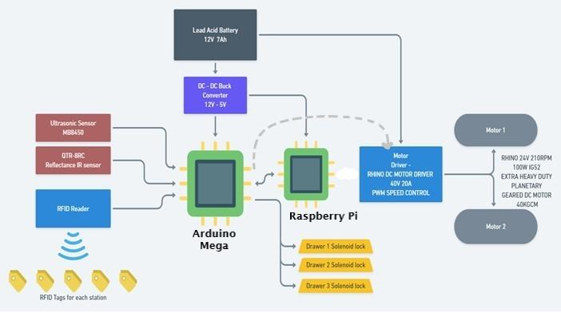
Electronic circuit working:
- The Raspberry Pi is the main central processing unit which will hold the OS for the Automated Ground Vehicle. The Arduino Mega is connected to a Raspberry Pi.
- The Arduino Mega will control the DC motor via. motor driver module which has PWM speed control.
- The Input components are Ultrasonic sensor, IR sensor and RFID reader for object detection, Line path following and RFID tag recognition tasks, respectively.
- Respective of the inputs from the sensors the outputs/actuation is done through DC motors and electric solenoid lock for automated guided vehicle movement and drawer unlocking, respectively.
- The Raspberry Pi updates all tasks through Wi-Fi and Bluetooth connectivity on the server to communicate with custom designed applications.

Power Distribution:
Main power source is a set of 7Ah 12V Lead Acid Batteries. The Batteries are connected in two sets of two series connected batteries for an output of 24V and totaling the capacity to 28Ah (7Ahx4).
The battery unit directly powers the four motors via a PWM type motor driver circuit.
The Electronic circuit unit is powered by stepping down the power supply from the batteries using a DC to DC buck converter to power the controllers Arduino Mega, Raspberry Pi, sensors, and actuators on the AGV.
AGV Operation
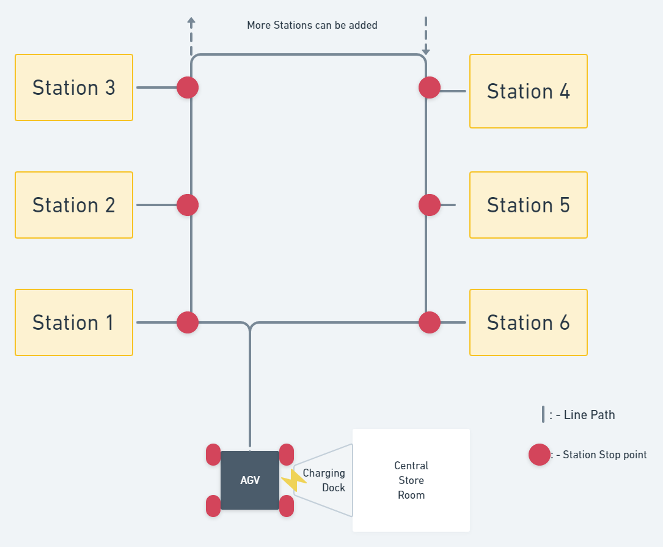

Description:
- AGV receives command and order for components from station(s)
- AGV gets loaded from central store room
- AGV follows line path using IR based line sensor
- AGV will detect for obstacles using sharp sensor
- AGV will detect its stops by reading the RFID tags on the respective station using a RFID reader.
- On reaching the destined station(s), the AGV will unlock its drawer compartment(s) to unload.
- On completing the order, the AGV will traverse back to the charging dock at the central store room.

CAD model
Base
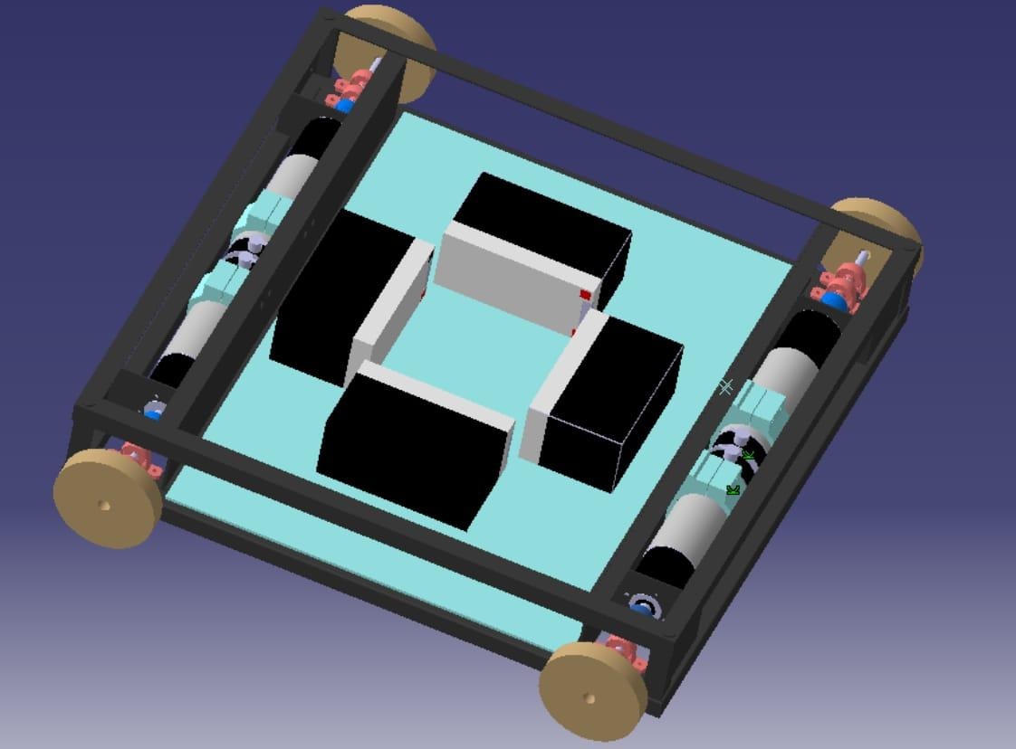
Drawer compartments assembly
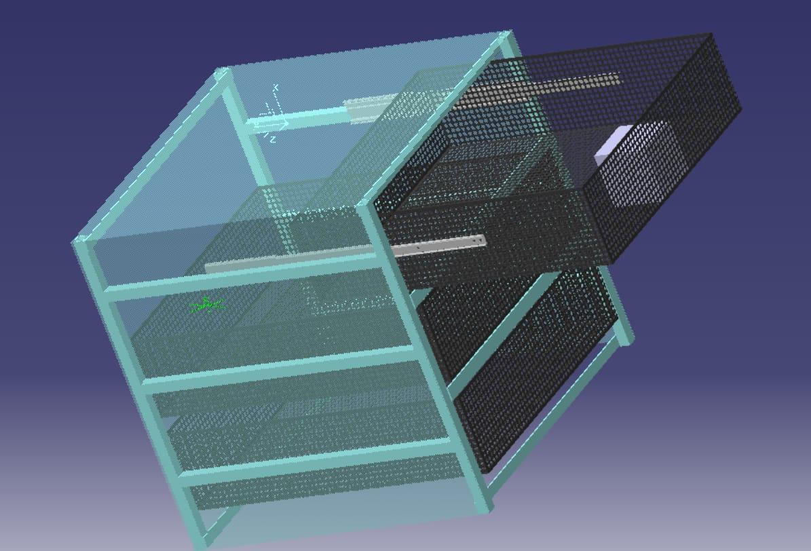
Single drawer compartment
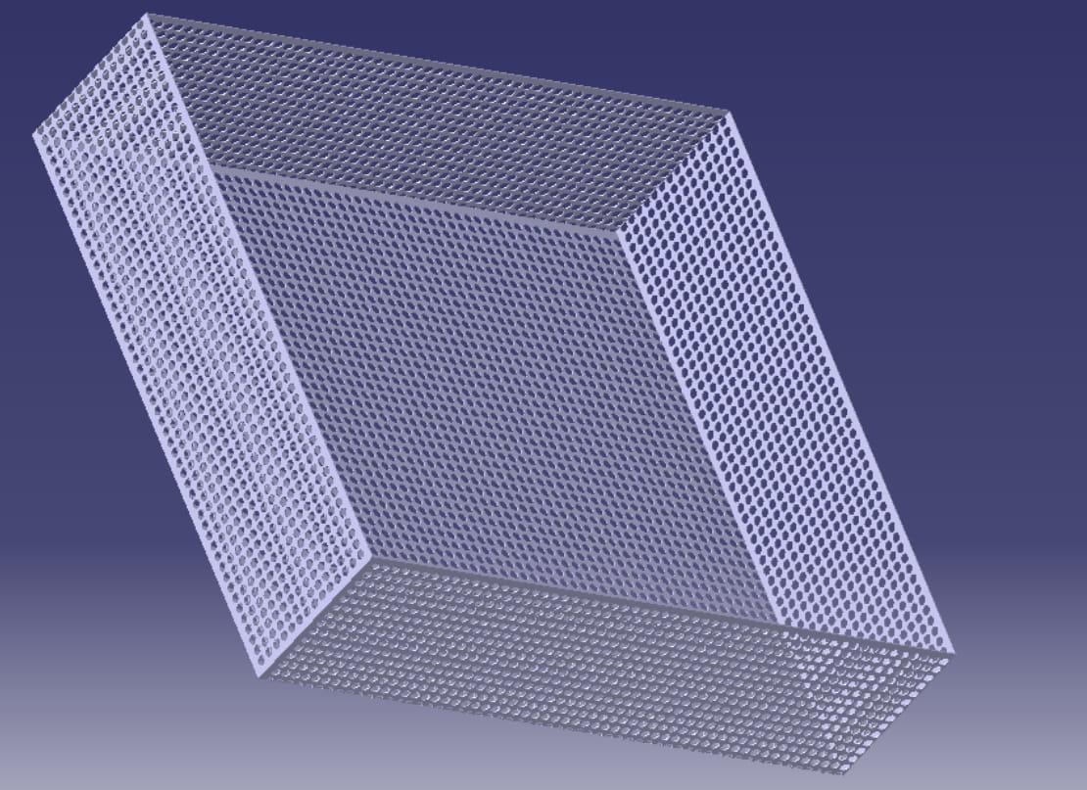
Assembled AGV
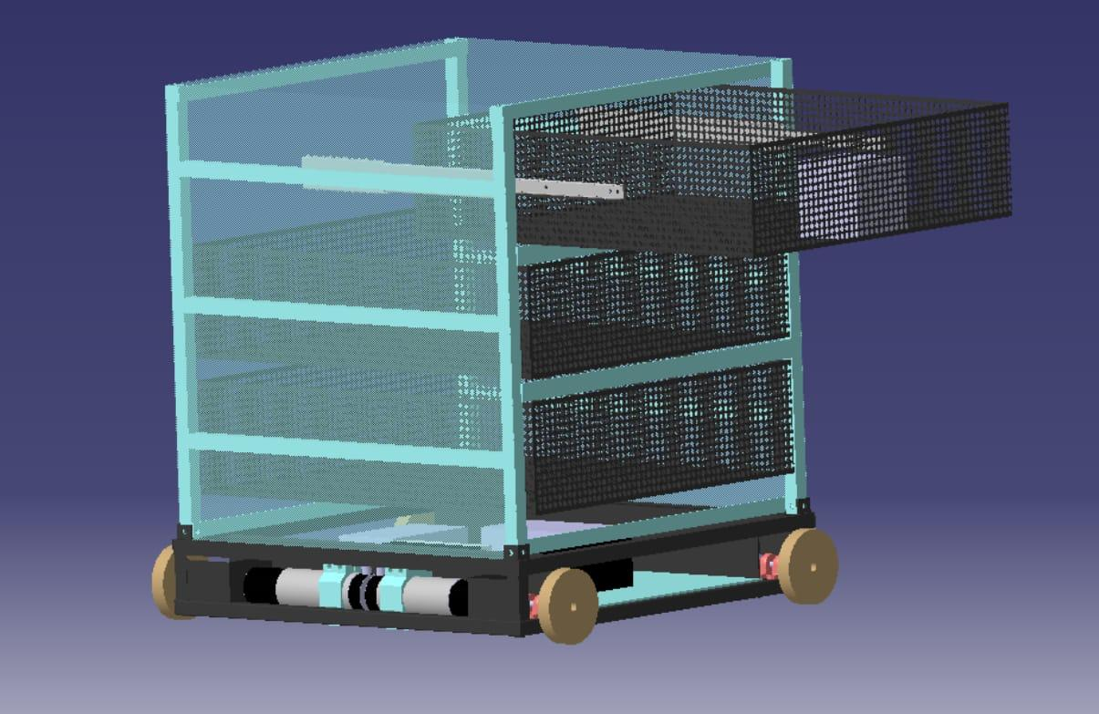

6. Methodology
Operation Flow chart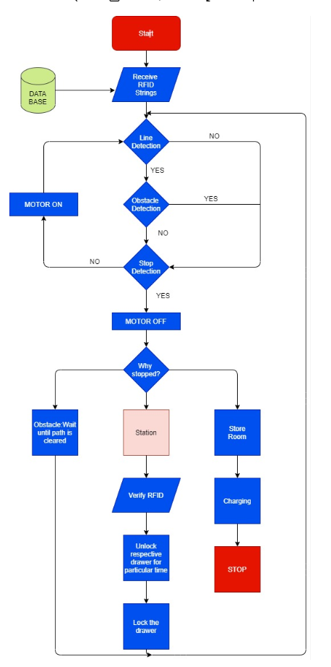
Operation description in brief:
The Automated Guided Vehicle (AGV) is a line following bot which delivers the goods from source to destination. With this we have created the flow diagram and here it is:
- Firstly, the AGV will get ready to deliver the goods by getting the information from database. The RFID numbers, stations numbers and other data is received by the AGV. Once this transfer is completed it will start following the line and reach the stations.
- The line detection is done simultaneously with obstacle detection and stop detection. Let’s take some examples to understand the flow if one three conditions occurred
    - Line detection
    - Obstacle detection
    - Stop detection.
Conditions
        - If the line is detected, then it will follow the line. To have the motor ON there should not be any obstacle and any stop. If all these conditions are satisfied then the motor will be ON and AGV will follow the line and it will remain in that loop unless any of the conditions is not satisfied.
        - If an obstacle is detected, then motors are OFF and will remain OFF unless the obstacle is being cleared.
        - If a stop/station is being detected, then the motor will be OFF. The condition will be to check why motors are OFF. Once confirmed there is a station then next steps verification and goods delivery will be performed.
        - If a stop/station is being detected, then the motor will be OFF. The condition will be to check why motors are OFF. Once confirmed there is a stop then the AGV will be charged.
- When AGV is at the station the verification process will start. The AGV will verify the identity by the RFID tags. Once confirmed, the respective drawer will be unlocked. The verified person can pull the drawer to get his goods/materials. Again, he will scan the RFID and lock the drawer.
- The location of AGV and the delivered material notification will be sent to the database and the mobile applications.
- This process continues until it will detect the stop once detected it will get back to the charging.

7. Hardware and Software Requirement
Hardware -
- AGV Chassis – Total dimensions (mm)– 600x600x700 (LxBxH)
- 3 Compartment drawer dimensions – 600x600x200
- Components compartment dimensions – 600x600x150.
- Wheel dimension – 150
- Lead Acid Battery 12V 7Ah – 4 (Set of 2 in series, in parallel for an output of 24V)
- Arduino Mega ATMega 2650
- Raspberry Pi zero
- Wireless transmission antenna
- I2C module
- DC-DC Buck converter of output 5V
- 12V battery charging circuit
- Single strand wires
- Multiple strand wires
- Electronic solenoid lock
- IR proximity sensors
- Sharp IR distance sensor
- RFID reader and tags of frequency 13.56Mhz
- Planetary Gear DC Motor 24V 100W 40Kgcm Torque 210 rpm
- DC Motor driver circuit 40V 20A with PWM speed control
- Motor Shaft coupling
- Shaft holder with bearings
- Motor holder mount
- Grub screws for motor shaft
- Drawer mounting sliders -6
- Drawer Compartments -3

Software -
- V-REP - The robot simulator CoppeliaSim, with integrated development environment, is based on a distributed control architecture: each object/model can be individually controlled via an embedded script, a plugin, a ROS or BlueZero node, a remote API client, or a custom solution. This makes CoppeliaSim very versatile and ideal for multi-robot applications. Controllers can be written in C/C++, Python, Java, Lua, Matlab or Octave.

- MICROCHIP STUDIO (FORMERLY ATMEL STUDIO) - ATMEL STUDIO is the integrated development platform (IDP) for developing and debugging all AVR and SAM microcontroller applications. The Atmel Studio IDP gives you a seamless and easy-to-use environment to write, build and debug your applications written in C/C++ or assembly code. It also connects seamlessly to the debuggers, programmers and development kits that support AVR and SAM devices.

- KEIL IDE - The µVision IDE combines project management, run-time environment, build facilities, source code editing, and program debugging in a single powerful environment. µVision is easy-to-use and accelerates your embedded software development. µVision supports multiple screens and allows you to create individual window layouts anywhere on the visual surface. The µVision Debugger provides a single environment in which you may test, verify, and optimize your application code. The debugger includes traditional features like simple and complex breakpoints, watch windows, and execution control and provides full visibility to device peripherals.
- Visual Studio- Microsoft Visual Studio is an integrated development environment (IDE) from Microsoft. It is used to develop computer programs, as well as websites, web apps, web services and mobile apps.Visual Studio includes a code editor supporting IntelliSense (the code completion component) as well as code refactoring.
8. Result analysis and discussion
The AGV CAD model was imported in V-REP software, where it was simulated to perform the following tasks.
- To perform line following.
- To identify the station stops.
- To lock and unlock the drawer compartments whenever and wherever required.
- To respond to multiple orders and deliver efficiently.
V-REP Simulation interface
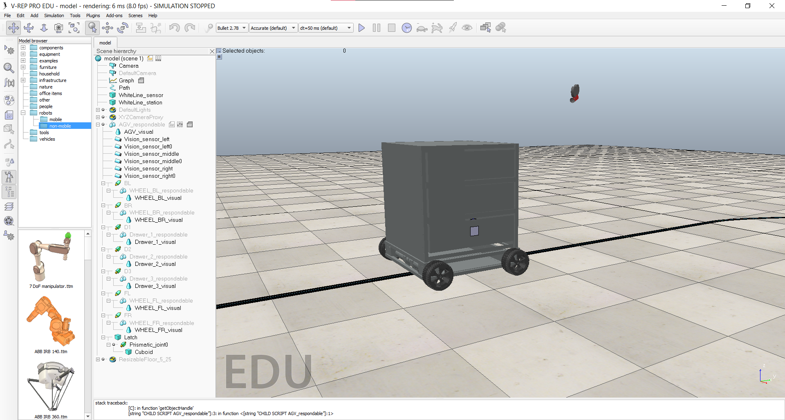

Discussion on Power consumption

Power calculation for 1 motor:
 | PWM | CURRENT  (A) | VOLTAGE (V) | POWER  (W)
1 | 40 | 0.07 | 23.9 | 1.673
2 | 80 | 0.15 | 23.9 | 3.585
3 | 100 | 0.2 | 23.9 | 4.78
4 | 127 | 0.28 | 23.9 | 6.692
5 | 200 | 0.3 | 23.9 | 7.17
6 | 240 | 0.29 | 23.9 | 6.931

Power calculation for 2 motors:
 | PWM | CURRENT  (A) | VOLTAGE (V) | POWER  (W)
1 | 40 | 0.15 | 23.9 | 3.585
2 | 80 | 0.36 | 23.9 | 8.604
3 | 100 | 0.48 | 23.9 | 11.472
4 | 127 | 0.6 | 23.9 | 14.34
5 | 200 | 0.67 | 23.9 | 16.013
6 | 240 | 0.68 | 23.9 | 16.252

9. Applications
- Raw material handling.
- Heavy equipment and parts deliver upto 80 Kilograms.
- Work-in-process movement Parts/Tooling delivery.
- Finished goods movement.
- Removal of waste.
- Hazardous materials handling.
- Conveyor Pick-up / Drop-off- This is very typical application where materials are transported between industrial processes and stations.
- Within Industry logistics.
- Multiple AGV network.
- Synchronized delivery and logistics platform.
- Unmanned autonomous logistics.

10. Future scope
LiDAR (Light Detection and Ranging) Sensors
When placed on an AGV, a LiDAR sensor transmits a collection of laser pulses that measure the range between objects and the vehicle itself. This compiled data creates a full 360° environmental map of the operational area, and the subsequent mapping enables the AGV to navigate throughout the facility without any additional infrastructure.
As a result, LiDAR sensors provide systems increased flexibility. Although LiDAR has been around for several years, the cost of these units continues to drop, meaning more and more companies will begin incorporating LiDAR onto their vehicles. Look for LiDAR to make an even bigger impact on the AGV industry in the years to come.
Camera Vision
AGV computer systems and camera-based vision often work hand-in-hand with LiDAR sensors to provide vehicle navigation. The camera’s ability to capture information in real time helps vehicles operate in actual manufacturing and warehousing environments. This data allows vehicles to “see” obstacles and plant infrastructure and, when combined with range information provided by LiDAR sensors, creates a dynamic, complete 3D image of an operational area.
However, the ways in which camera technology can be applied to AGV systems extend beyond navigation. In the future, cameras could improve how vehicles detect pallets, allowing them to interact more effectively with manual vehicles. This technology may also enable stand-alone vehicles to operate more efficiently inside facilities.
Dual-Mode AGVs
Dual-mode AGVs, which can be operated manually or automatically, have been on the market for several years already. However, users have often struggled to use these vehicles as designed. Toggling between manual and automatic proved unreliable and ineffective. Nevertheless, with the accuracy and dependability of sensors placed on AGVs continually increasing, the future of dual-mode vehicles looks bright.
Improving technology combined with ever-advancing applications knowledge means that the issues typically encountered in these types of AGVs may soon disappear. As forklift manufacturers begin to cooperate with AGV experts, a viable solution to the pitfalls of prior iterations of dual-mode vehicles could soon emerge.
Software
Even with these individual pieces of technology contributing to the futures of AGVs, software still plays the largest role in the evolution of the industry. It often serves as the backbone of an AGV system. By coordinating functions like vehicle communication, order generation, and traffic control, software distinguishes the “good” systems from the “bad” ones. Even in stand-alone systems, the software programmed into the AGVs dictates the efficacy of the system.
As such, the applications knowledge of software development and engineering teams holds the greatest potential to transform the AGV industry. Their abilities can solve the unique challenges of individual facilities and can implement specific pieces of technology to best suit certain applications. This power translates into AGV systems that provide solutions, rather than simply vehicles, for those that implement driverless units.

11. Prototype model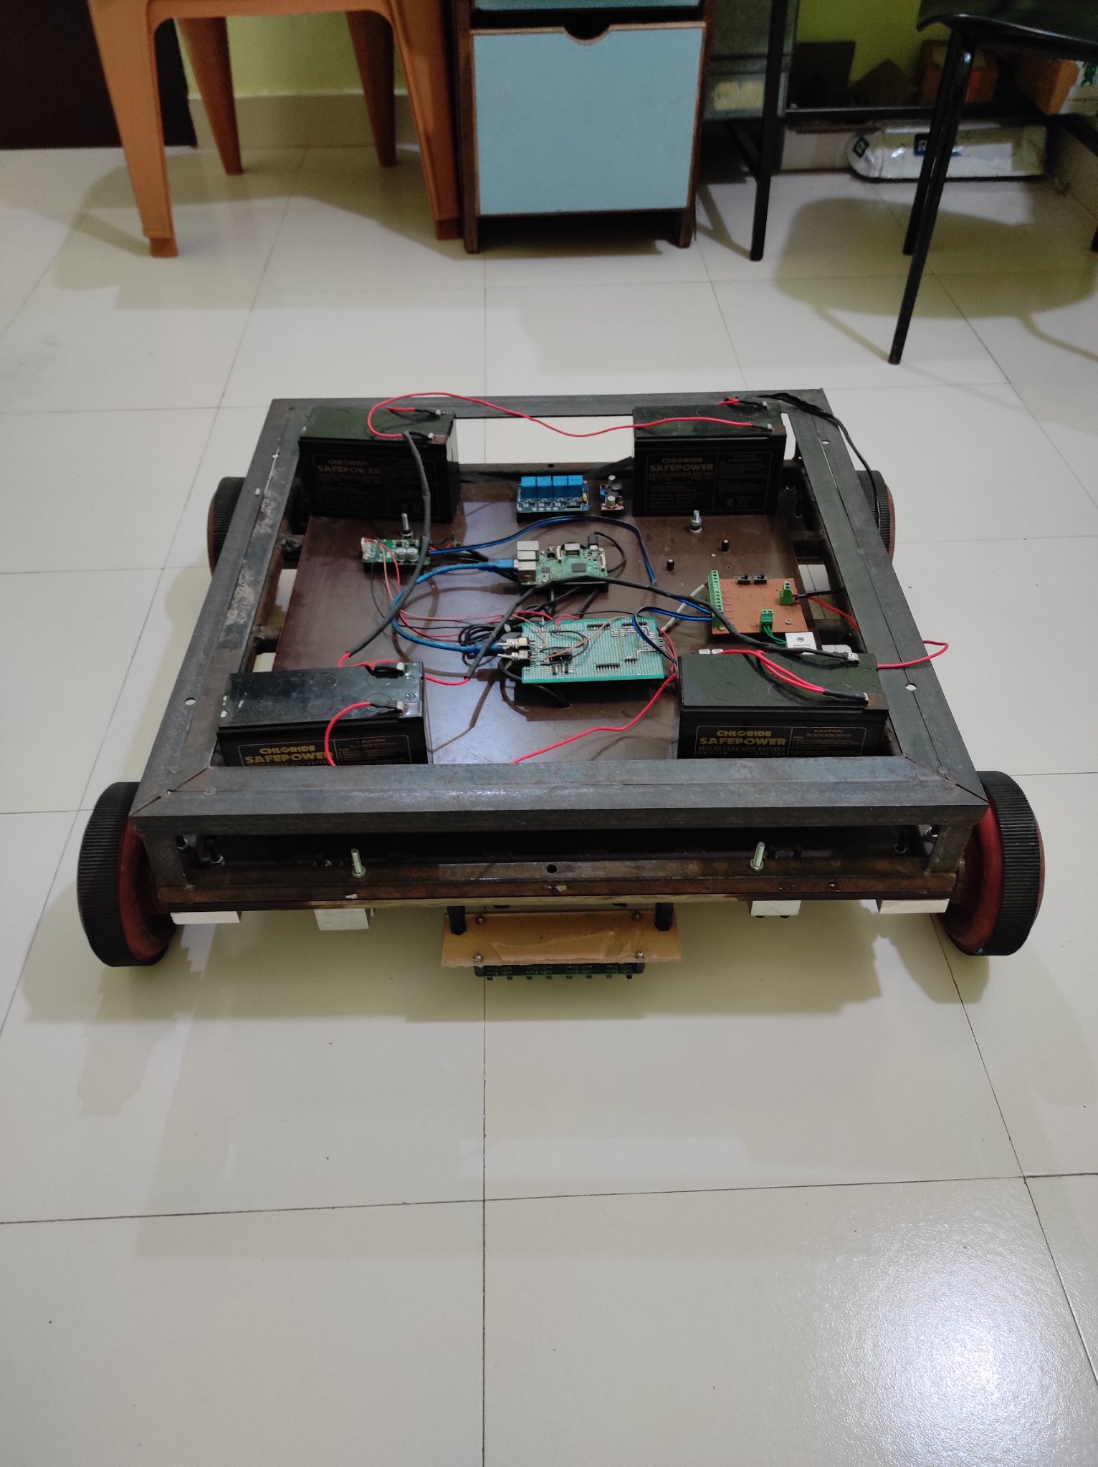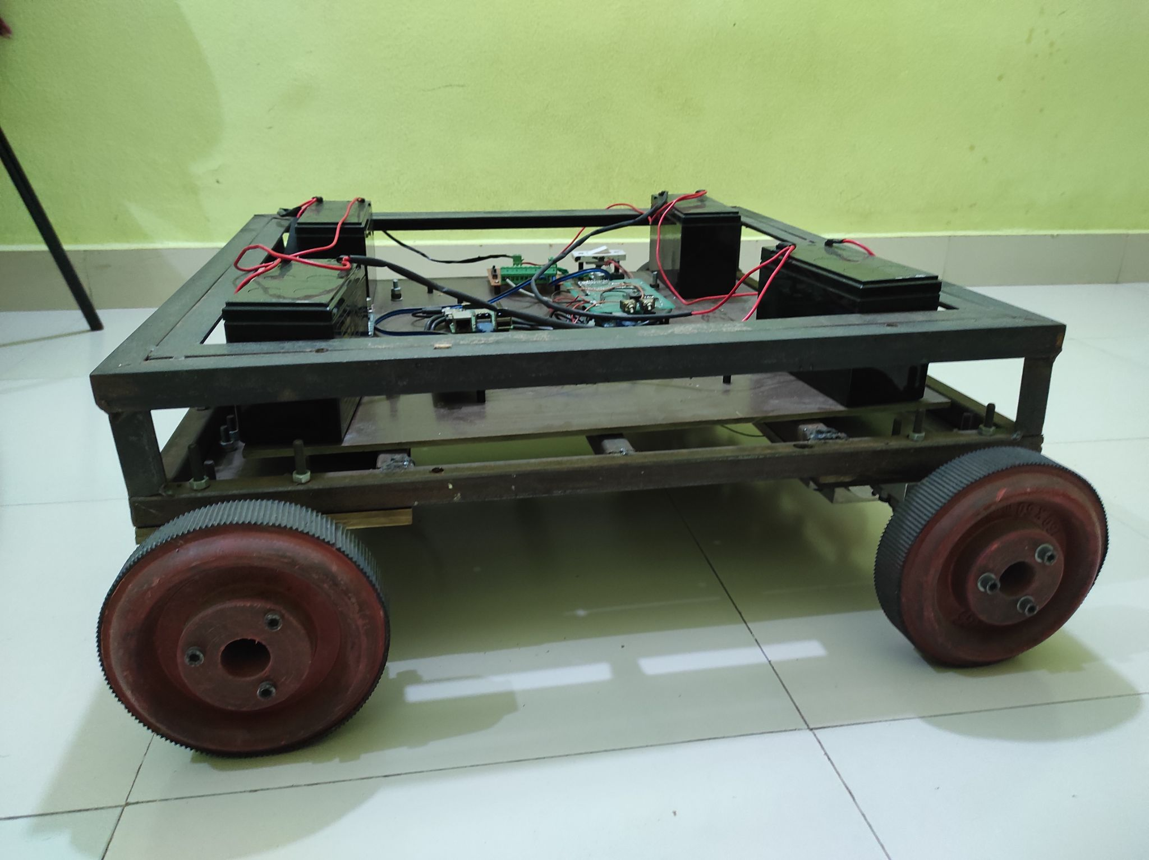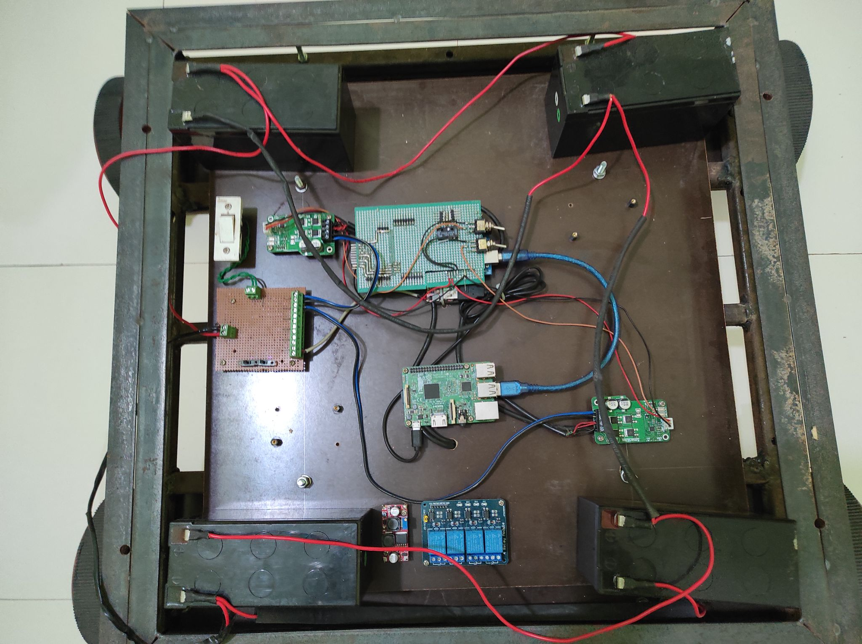
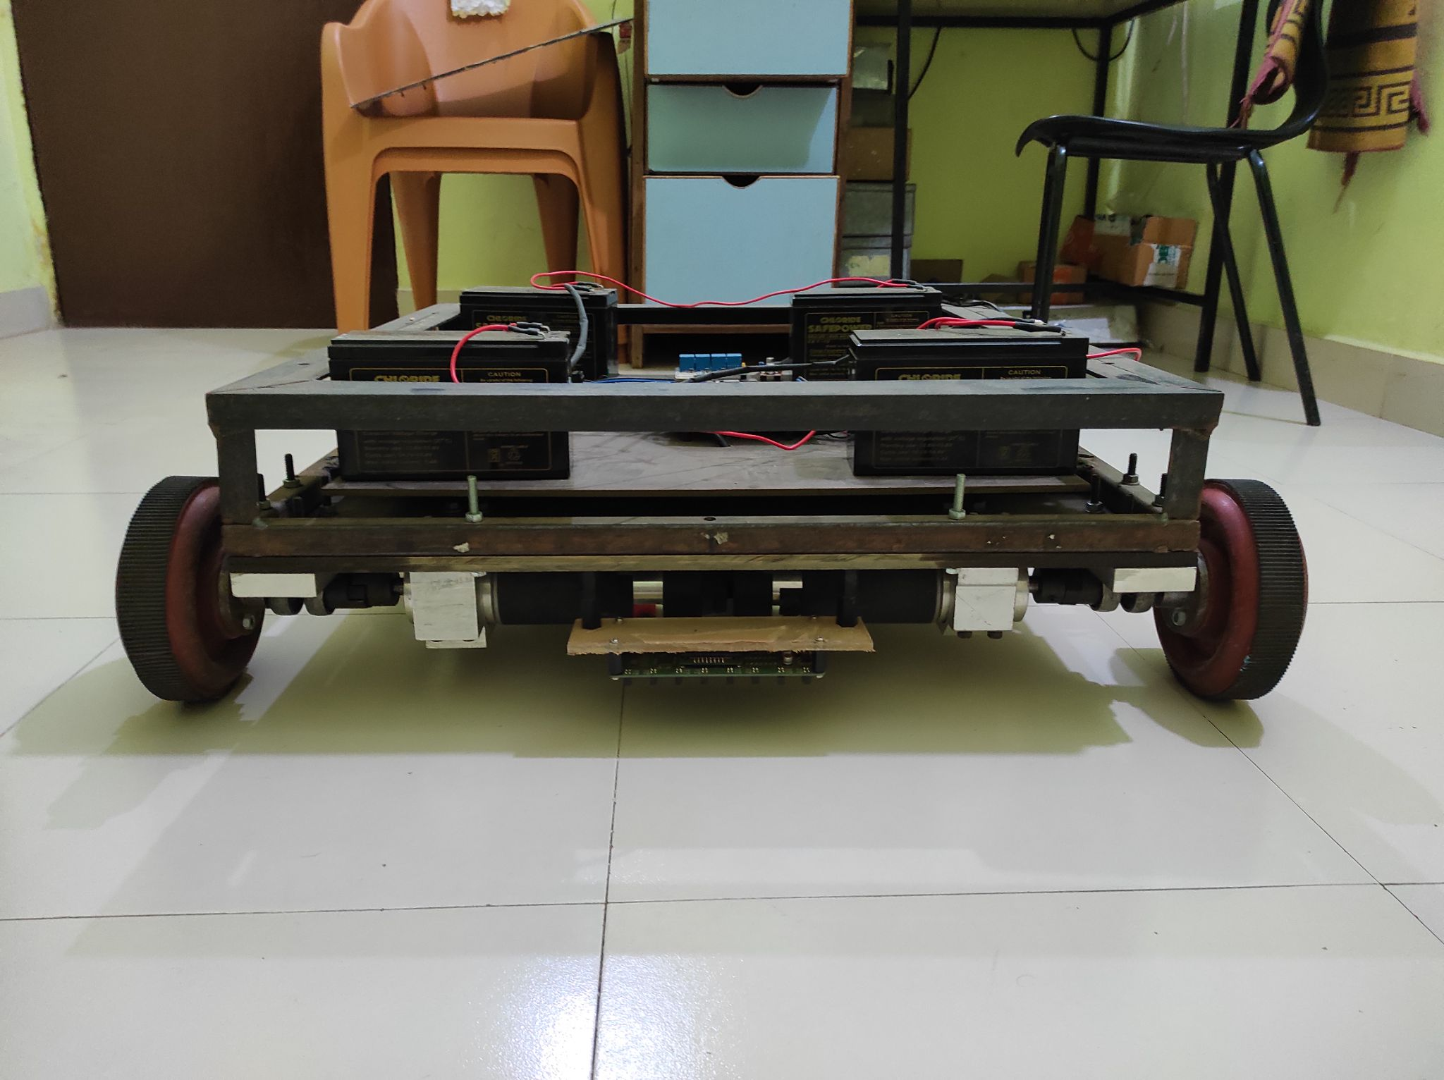
Conclusion-
While automation has had a presence in the material handling sector for years, its ever-increasing implementation rates could transform the way that we envision manufacturing. Some completely automated facilities already exist, and the number of these sites continues to grow. AGVs play a significant role in the evolution of manufacturing, due in large part to the aforementioned technologies.
References

- Kaijun Zhou 1,2, Lingli Yu 3, * ID , Ziwei Long 3 and Siyao Mo, " Local Path Planning of Driverless Car Navigation Based on Jump Point Search Method Under Urban Environment", Journal of Future Internet 2017, 9,pp 2-13 51; doi:10.3390/fi9030051
- Tang, B.W.; Zhu, Z.X.; Luo, J.J. Hybridizing Particle Swarm Optimization and Differential Evolution for the Mobile Robot Global Path Planning. Int. J. Adv. Robot. Syst. 2016, pp 1–17.
- Mauricio F. Jaramillo Morales, Juan B. G´omez Mendoza (2019), "Mixed Energy Model for a Differential Guide Mobile Robot",
- C. Goerzen, Z. Kong, B. Mettler, (2010), "A Survey of Motion Planning Algorithms from the Perspective of Autonomous UAV Guidance", Journal of Intelligent Robot System, pp-65-100,

Name of Project Guide
Prof. R. S. Pol

